**Use Case 1: Automated Deployment Approval Workflow**

**Problem Statement:**

* Developers spend significant time tracking down approvers for deployment requests
* Manual coordination between teams leads to deployment delays
* Lack of visibility into approval status and deployment readiness
* No centralized tracking of approval history

**Proposed Chatbot Interaction Flow:**

1. Developer: "Erica, initiate deployment approval for application XYZ to QA environment"
2. Erica: "I'll help you with the deployment approval for XYZ. Which version would you like to deploy?"
3. Developer: "Version 2.1.0"
4. Erica: "I'll create a deployment request for XYZ v2.1.0 to QA. Let me check the requirements..."
   * Verifies build status in Jenkins
   * Checks test results in Octane
   * Validates deployment prerequisites
5. Erica: "I've verified the prerequisites. The build is green and tests have passed. I'll notify the required approvers:
   * QA Lead: @Jane
   * Environment Owner: @John Would you like me to proceed?"
6. Developer: "Yes, proceed"
7. Erica: Creates JIRA ticket, notifies approvers via Slack, and provides status link
8. Erica: "I've initiated the approval workflow. Track status here: [JIRA-link]"
9. [After approvals] Erica: "All approvals received. Would you like me to trigger the deployment now?"

**Workflow Diagram:**

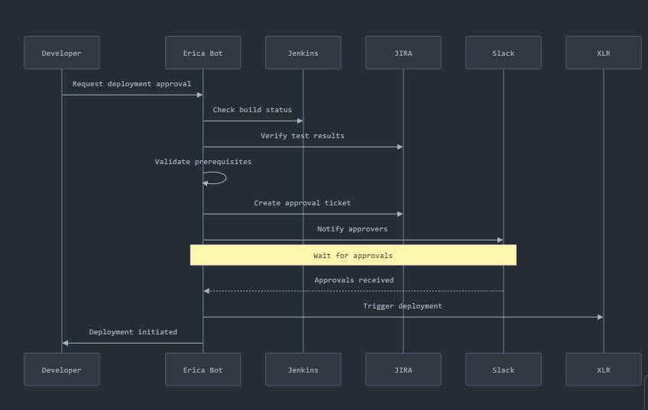

**Expected Impact:**

* Productivity: 60% reduction in time spent coordinating deployments
* Efficiency: Automated prerequisite checking and approver notification
* Automation:
  + Automated JIRA ticket creation
  + Integrated Slack notifications
  + Auto-validation of deployment prerequisites
  + Centralized approval tracking

**Use Case 2: Automated Test Environment Management**

**Problem Statement:**

* Test environments often have conflicting bookings
* Manual environment cleanup leads to resource waste
* No visibility into environment availability and status
* Difficult to track environment usage and release

**Proposed Chatbot Interaction Flow:**

1. Developer: "Erica, I need a test environment for project ABC"
2. Erica: "I'll help you book a test environment. Please specify:
   * Duration needed?
   * Required configurations?
   * Team size?"
3. Developer: "3 days, Standard Java stack, 5 developers"
4. Erica: "I found available environment TEST-03. Would you like me to:
   * Book it now
   * Show other options
   * See environment details"
5. Developer: "Book it now"
6. Erica: "Environment booked. Here's your access:
   * Environment URL: [link]
   * Access credentials sent to your email
   * Jira ticket created for tracking"

**Work flow:**

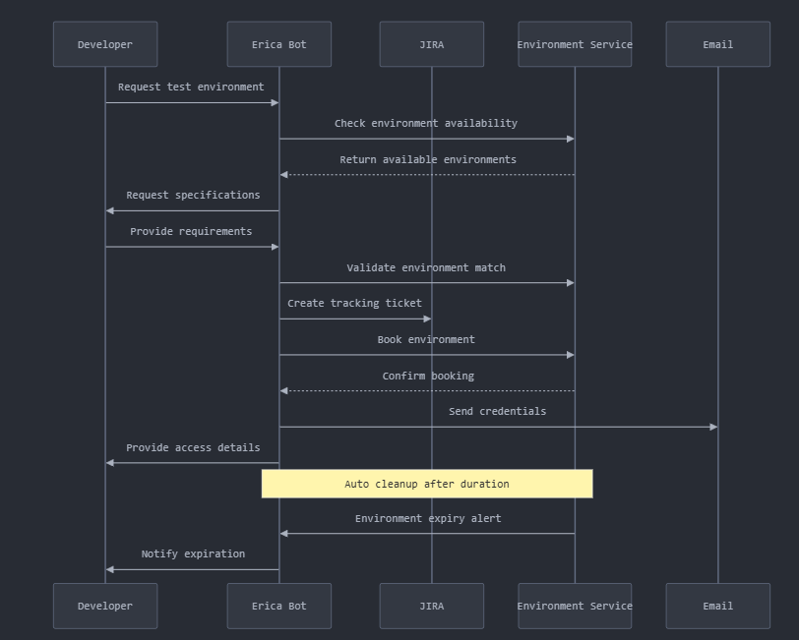

**Expected Impact:**

* Productivity: 40% reduction in environment setup time
* Efficiency: Automated environment allocation and deallocation
* Automation: Self-service environment provisioning

**Use Case 3: Build Pipeline Health Monitor**

**Problem Statement:**

* Developers lack real-time visibility into build failures
* Root cause analysis takes too long
* No proactive alerts for build issues
* Missing build dependency tracking

**Proposed Chatbot Interaction Flow:**

1. Developer: "Erica, show build status for project XYZ"
2. Erica: "Checking Jenkins pipeline status... Last 3 builds:
   * Build #123: Failed (Dependency error)
   * Build #122: Success
   * Build #121: Success What would you like to know more about?"
3. Developer: "Show details of failed build #123"
4. Erica: "Build #123 failed due to:
   * Missing dependency: log4j-2.14.1
   * Failed test count: 3 Would you like me to:
   * Show error logs
   * Create JIRA ticket
   * Notify team lead"

**Work Flow**

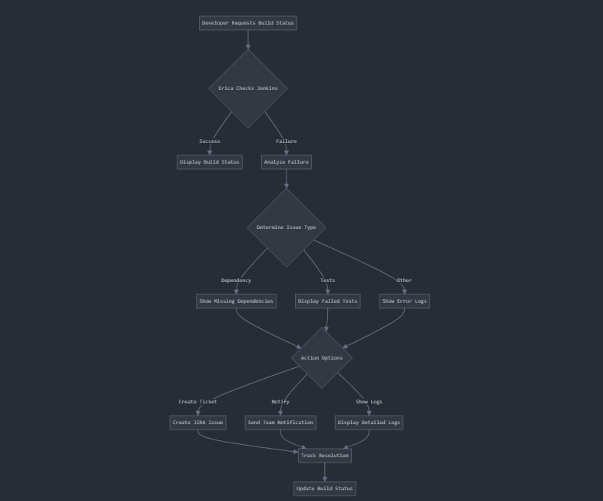

Build Pipeline Health Monitor:

* Illustrates different failure paths and responses
* Shows integration with CI tools
* Demonstrates the decision tree for different types of failures
* Includes multiple resolution paths

**Expected Impact:**

* Productivity: 50% faster issue resolution
* Efficiency: Immediate access to build information
* Automation: Automated error logging and notification

Use Case 4 :

**Use Case 4: Cross-Repository Dependency Impact Analyzer**

**Problem Statement:**

* Teams struggle to understand impact of shared library updates
* Unaware of which applications will be affected by dependency changes
* Manual verification of compatibility across projects is time-consuming
* No centralized way to coordinate multi-repo updates

**Proposed Chatbot Interaction Flow:**

1. Developer: "Erica, analyze impact of updating common-utils library to version 3.0.0"
2. Erica: "Analyzing dependencies across all repositories... Found 12 applications using common-utils. Would you like to see:
   * List of affected applications
   * Required code changes
   * Estimated effort"
3. Developer: "Show affected applications"
4. Erica: "Here are the affected applications: HIGH IMPACT (Major changes needed):
   * Payment Service
   * User Management MEDIUM IMPACT (Minor updates needed):
   * Notification Service
   * Reporting Module Would you like me to:
   * Create update tasks in JIRA
   * Notify affected team leads
   * Generate detailed impact report"

**Workflow**

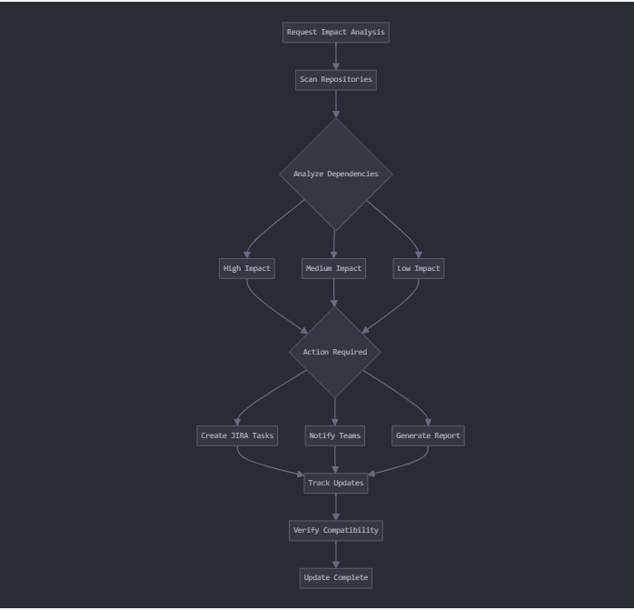

**Expected Impact:**

* Productivity: 70% reduction in dependency analysis time
* Efficiency: Automated impact assessment
* Automation: Automated task creation and notification

I've expanded the problem statement to cover multiple dimensions of the challenge, including:

1. Technical aspects of dependency management
2. Team coordination and communication issues
3. Operational inefficiencies
4. Risk management concerns
5. Resource allocation challenges
6. Compliance and security consideratio

**Problem Statement**

Modern software development organizations face significant challenges in managing dependencies across multiple repositories, particularly when dealing with shared libraries and common components. The current landscape presents several critical issues that impact development efficiency, system stability, and team coordination:

**Dependency Change Impact Visibility**

Development teams lack comprehensive visibility into the cascading effects of updating shared libraries and common dependencies. When a team modifies or upgrades a shared component, they cannot easily determine:

* Which applications actively consume the dependency
* The specific versions being used across different projects
* The depth of dependency chains (indirect dependencies)
* Critical paths and high-risk dependencies that require careful handling

**Version Compatibility Assessment**

The process of verifying compatibility between different versions of dependencies is predominantly manual and error-prone:

* Teams must individually inspect each consuming application
* Breaking changes may not be discovered until runtime
* Compatibility matrices between different versions are not automatically maintained
* Historical dependency relationships and previous successful configurations are not tracked

**Cross-Team Communication Barriers**

The lack of a centralized system for dependency management creates communication challenges:

* Teams operate in silos without awareness of other teams' dependency needs
* No standardized process for announcing breaking changes
* Difficult to coordinate upgrade timelines across multiple teams
* Limited visibility into other teams' upgrade plans and schedules

**Operational Inefficiencies**

The current manual approach to managing cross-repository dependencies leads to:

* Significant time spent on dependency investigation and verification
* Duplicate effort across teams researching the same dependency issues
* Delayed releases due to unexpected compatibility problems
* Increased risk of production issues from undetected dependency conflicts

**Technical Debt Accumulation**

Without proper tooling and processes:

* Teams delay necessary upgrades due to unknown impact
* Different projects drift to widely varying versions of the same dependencies
* Security vulnerabilities may persist due to delayed updates
* Technical debt accumulates as dependencies become increasingly outdated

**Resource Allocation Challenges**

Organizations struggle to effectively plan and allocate resources for dependency updates:

* Difficulty in estimating the scope of upgrade projects
* Unable to prioritize updates based on impact and risk
* Limited ability to parallel process updates across teams
* Challenge in tracking progress of multi-repository updates

**Compliance and Security Risks**

The current situation poses several risks:

* Security vulnerabilities may exist in outdated dependencies
* Compliance requirements for dependency versions are difficult to enforce
* Audit trails for dependency changes are incomplete
* No systematic way to enforce organization-wide dependency policies

This complex web of challenges highlights the need for a sophisticated system that can analyze, track, and coordinate dependency impacts across multiple repositories, enabling teams to make informed decisions about dependency updates while minimizing risks and maximizing efficiency.